|  |
| --- |
| **CARRICULUM VITAE**  **MST.AKLIMA AKTER**  **Contact No.+8801722380680**  **E-mail: aklima15-14758@diu.edu.bd** |

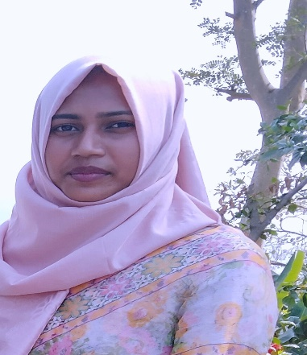

**CAREER OBJECTIVE**

**To obtain a position with opportunities to utilize my technical and marketing experience , skill , talent ,creativity ,sincerity for the better achievement of the organization**.

**LANGUAGES SKILL**

**Bengali and English Writing and writing, reading speaking**

**E D U C A T I O N**

**Computer Science and Engineering**

Daffodil International University

2021-2025

**Higher Secondary school certificate**

RASHEDAZZOHA GOVT. WOMEN’S COLLEGE SIRAJGONG

2017-2019

**Secondary School Certificate**

**Gandhail R.U.A.A. High School**

**2015-2016**

**HOBBIES**

**Travelling, Reading and Music.**

**TECHNICAL SKILL**

**1. Programming Technologies -C**

**2. Web Programming Technologies - HTML.**

**3.Office Tools: Microsoft word 2019**

**4.Operating Systems - Windows**

ACHIVEMENTS

**Solved more than 1000 problems in varies online judges.**

**PROJECT**

**1.Result Generator**

**2.Book Your Movie**

**REFERENCES**

**Dr………**

**[Department…………]**

**[University]**